Applicability:
The following will provide step-by-step instructions to set up the GPIO port on your DCi Network amp for VCA control. VCA controllers shown will be the Crown VCAP and the JBL CSR-V. *Note: Audio Architect software is required. This note assumes you already know how establish a network connection and bring your amplifier up in Audio Architect. If not please refer to System Technology Bulletin #000x*

Part Description:
Crown: 1VCAP
JBL: CSR-V
- With your DCi Network amplifier connected to your network, launch Audio Architect.
- In Discovered Devices, drag over to the Room 1 tab the amplifier you want to set up. Right click on the face of the amplifier and select Configure Control Ports as shown in picture below.
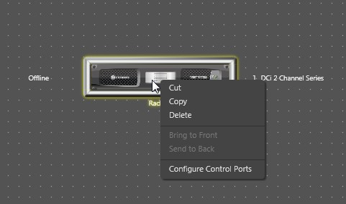

- For this example we will be selecting the Analog Input faders. If Blu Link is used you can select the faders to control via the Blu Link Inputs.
- When the Configuration window opens, click the small arrow next to Venue and keep expanding until the amplifier to control from your rack is open.
- With the Ch1 and Ch2 Analog Inputs expanded, you will see all your options available. You will see all options available per the picture below.
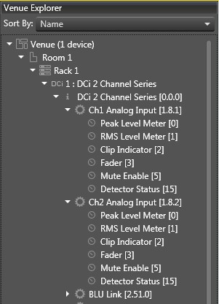

- The picture below shows the options above plus the Parameter Assignment section. You have two Input options available to assign functions. For the 2-CH DCi models you can assign Analog Input 1 Fader to Input 1 of the GPIO and Analog Input 2 Fader to Input 2 of the GPIO for two individual controls. In this example we will use Input 1 of the GPIO to control both channels Input faders.
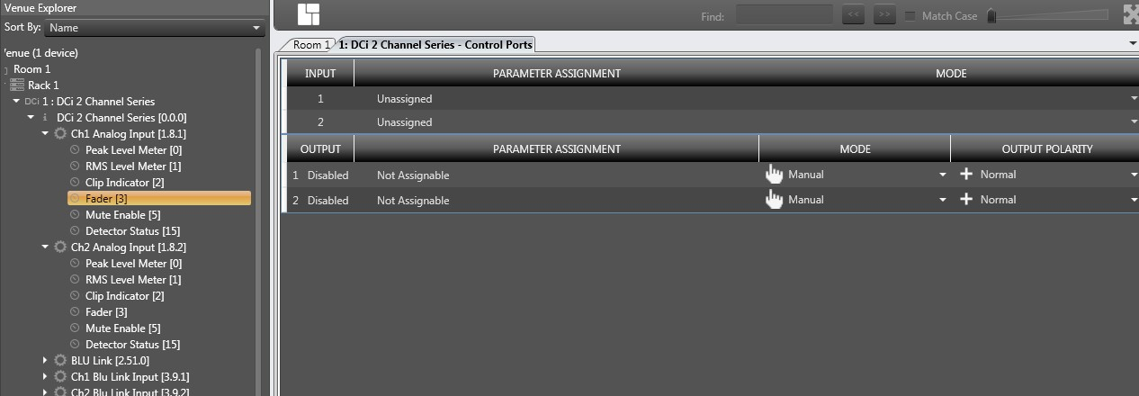

- To assign Input 1 of the GPIO with the faders to control, click and drag each Fader to the Input 1 Unassigned line as shown below.
- Next, click the small down arrow in the Mode Column and select Analog Input.
- Next you can set you High and Low Limit for the preferred dB range limits for your VCA control.
- Note: If the cable is disconnected from the GPIO port, wire break or pot failure, the output of the amplifier will default to the Low Limit value. This can be changed per Part 2 below of this note on wiring.
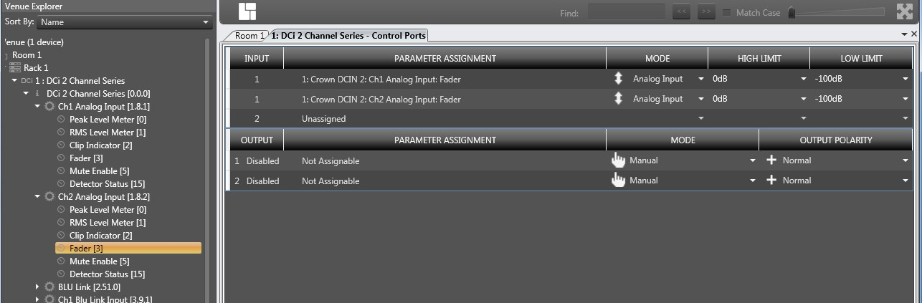

DCiN GPIO – VCA Configuration: Part 2; Wiring the 1VCAP and JBL CSR-V

Wiring the 1VCAP to the GPIO Option #1:
- **It should be noted from the start, the 1VCAP was originally designed for the CTs-MCVCA amplifiers. You will not be following the labeling found on the 1VCAP.
- The 1VCAP pin out is labeled +10V, CTRL and GND.
- The GPIO port is a RJ11 6 wire connection;
  - Pin 1: Output 1.
  - Pin 2: Output 2.
  - Pin 3: Input 1.
  - Pin 4: +3.3VDC
  - Pin 5: Input 2.
  - Pin 6: GND
- For this VCA wiring example we will be using Pin 3: Input 1, Pin 4: +3.3VDC and Pin 6: GND.
- As noted above about the 1VCAP wiring, the +3.3VDC on Pin 4 of your RJ11 is connected to the phoenix terminal on the 1VCAP marked GND.
- Pin 3: Input 1 wire from the RJ11 will connect to the phoenix terminal marked CTRL on the 1VCAP.
- Pin 6: GND wire from the RJ11 will connect to the phoenix terminal marked +10V on the 1VCAP.
- Wiring the 1VCAP and the programming of the GPIO as provided above will allow the pot to function as expected, turn CW the level increases, CCW the level decreases. If you swap the wire connected to the +10V and GND on the 1VCAP, your pot rotation will be reversed.
- Also again note: if the pot, connection to the GPIO or cable breaks, output level defaults to the Low Limit value set.

Wiring the 1VCAP to the GPIO Option #2:
- This option is for those who don’t prefer to have the output levels attenuate when the pot, cable or connection breaks.
- Pin 4: +3.3VDC wire of the RJ11 will connect to the phoenix terminal marked +10V on the 1VCAP.
- Pin 3: Input 1 wire from the RJ11 will connect to the phoenix terminal marked CTRL on the 1VCAP.
- Pin 6: GND wire from the RJ11 will connect to the phoenix terminal marked +10V on the 1VCAP.
- The above wiring is how one would expect to wire to the pot based on the 1VCAP labeling, but in this case you need to go back into your Configure Control Port section and change the High and Low Limit values.
- In this case the High Limit will be set at your desired low dB level, i.e.: -50dB. Then set the Low Limit for your desired high dB level, i.e.: -5dB.
- The pot will still respond as above in Option #1 but now if the pot, cable or connection breaks, the output of the amplifier will still default to the Low Limit which is now set at a higher dB level, in this case -5dB.

Wiring the CSR-V to the GPIO:
- The CSR-V uses a RJ45 connection, so you will need to make a RJ11 to RJ45 cable connection.
- The RJ11 wiring is still the same as mentioned in Option #1 above for the 1VCAP.
- The RJ45 pin out for the CSR-V is:
  - Pin 1: +3.3VDC
  - Pin 2: Volume Control
  - Pin 8: GND
  - Pin 3 to 7 are not used.
- Pin 4: +3.3VDC of the RJ11 will go to Pin 1: +3.3VDC on the RJ45.
- Pin 3: Input 1 wire from the RJ11 will go to Pin 2: Volume Control on the RJ45.
- Pin 6: GND from the RJ11 will go to Pin 8: GND on the RJ45.
- Note: This is the only wiring option for the CSR-V. If the connection is lost to the CSR-V your audio will attenuate to your Low Limit range set in your GPIO Configuration.

